2026
Nitheesh Kondapalli
ITA1416-Ethical Hacking
8/5/2026
Netsh Commands

netsh>interface show interface
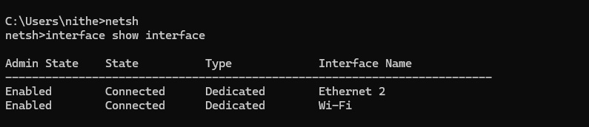

netsh>interface ipv4 show interfaces
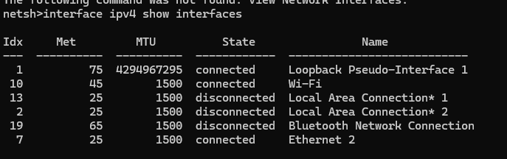

netsh>interface ipv6 show interfaces
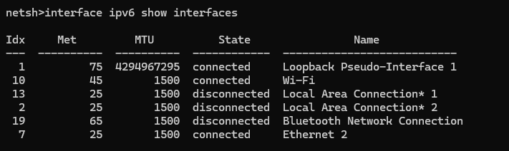

netsh>interface ip show config
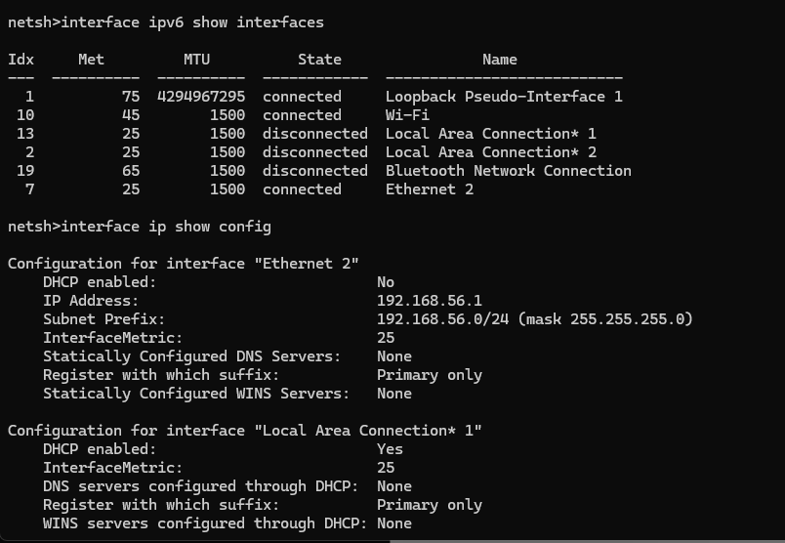

netsh>interface ipv4 show config
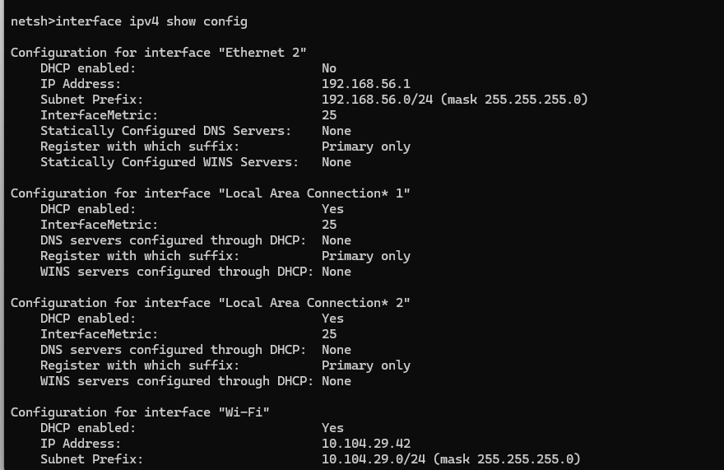
netsh>interface ipv6 show addresses
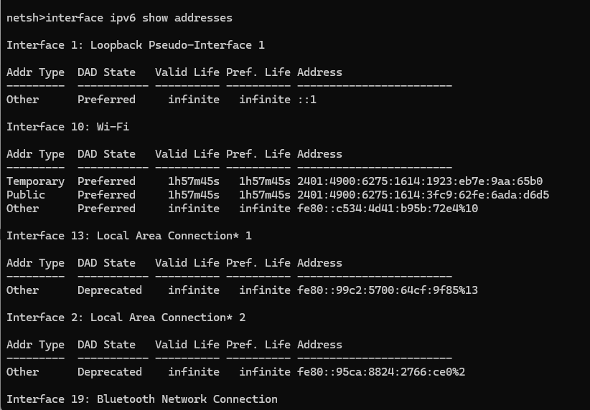
netsh>interface ipv6 show addresses
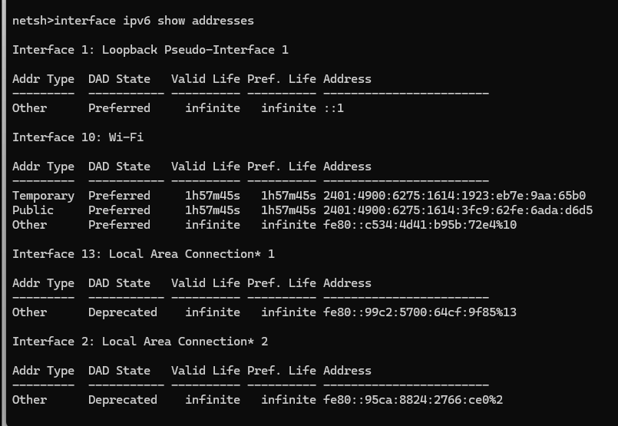

netsh>interface ipv4 set dns
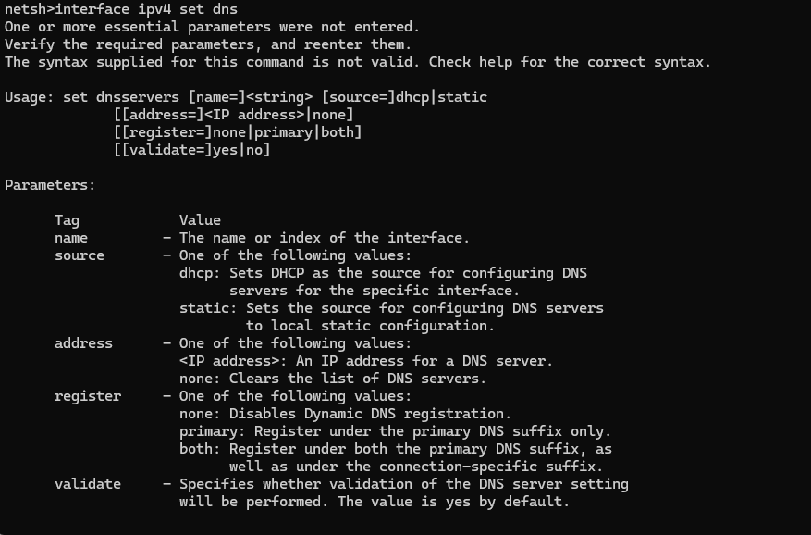

netsh>interface ipv4 set dns name="Ethernet" static 8.8.8.8
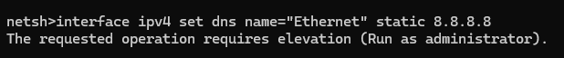
netsh>interface ipv4 set address name="Ethernet" static 192.168.1.100 255.255.255.0 192.168.1.1

netsh>interface ipv4 set address name="Ethernet" shource=dhcp
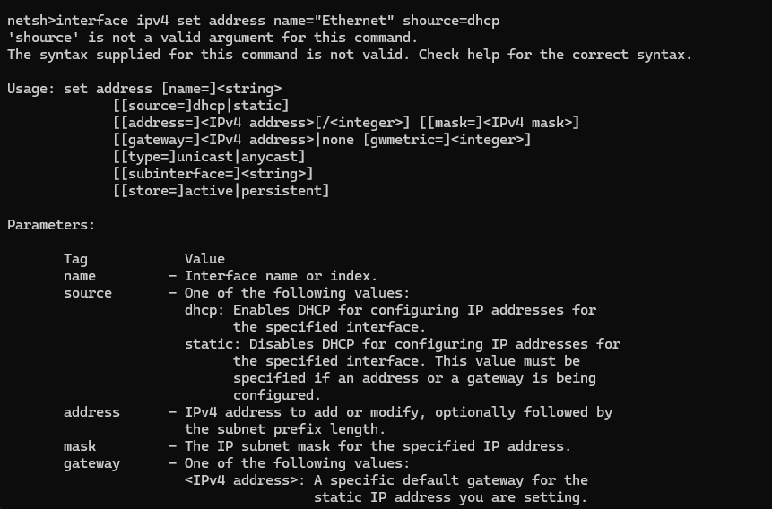
netsh>interface ipv4 set dns name="Ethernet" shource=dhcp
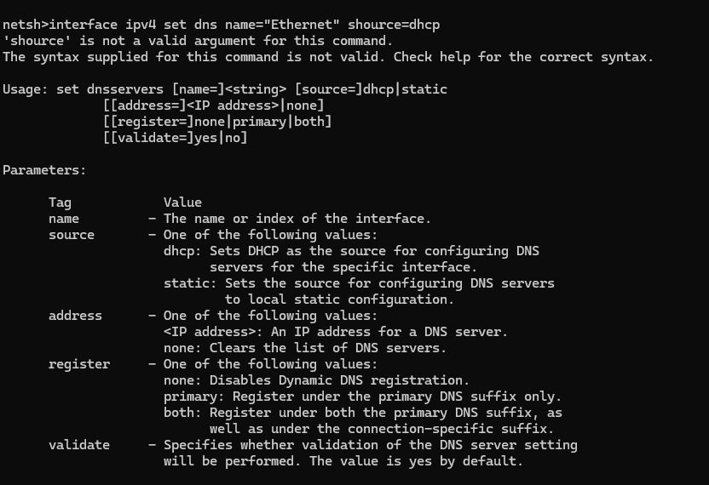

netsh>interface set interface "Ethernet" disable
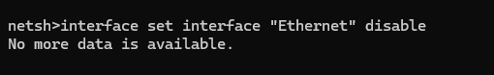

netsh>interface set interface "Ethernet" enable
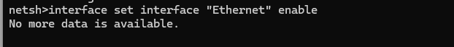

netsh>wlan show profile
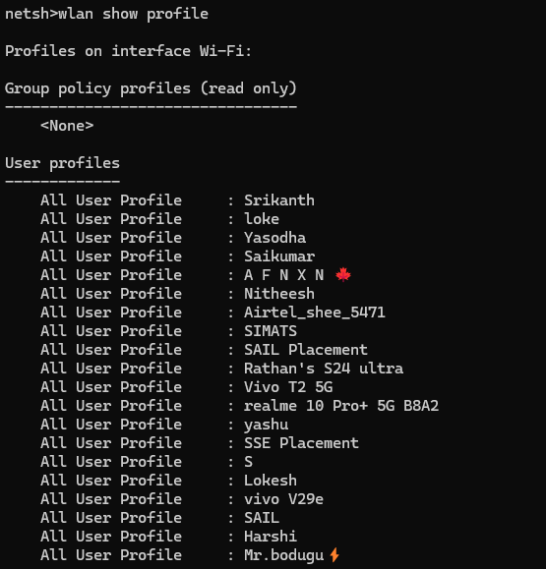

netsh>wlan show profile name="Munna" key=clear
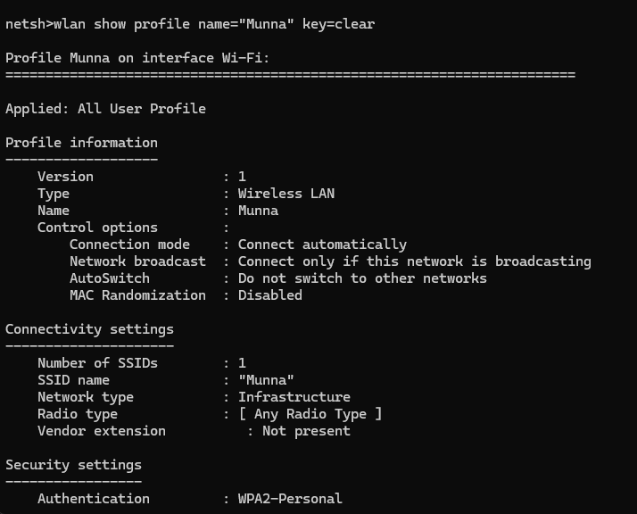
netsh>wlan export profile name="Munna" key=clear
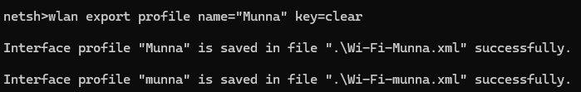

netsh>netsh>wlan delete profile name="Munna"
netsh>netsh>wlan delete profile name="Munna"
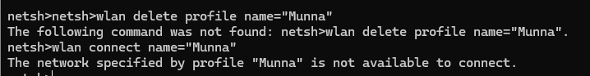

netsh>wlan show drivers
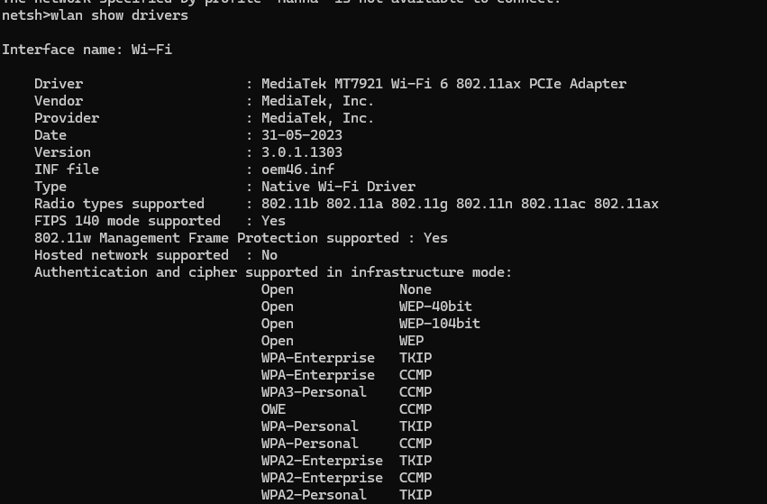

netsh>wlan show networks mode=bssid
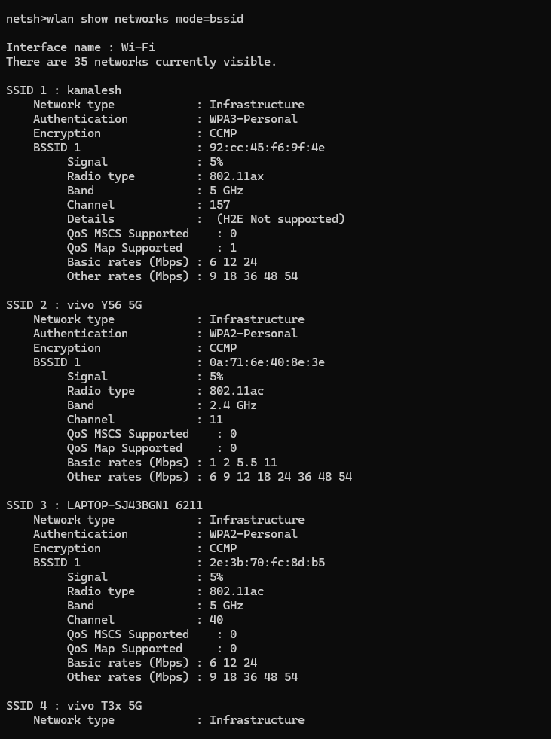

netsh>wlan stop hostednetwork
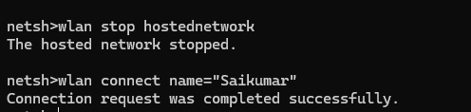

netsh>advfirewall show currentprofile
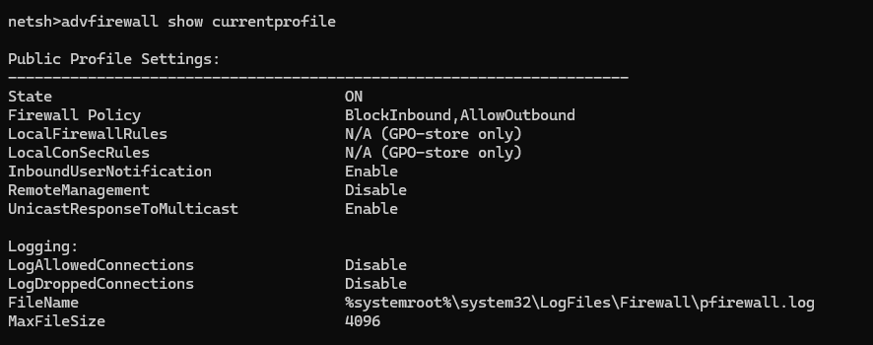

netsh>advfirewall show allprofile
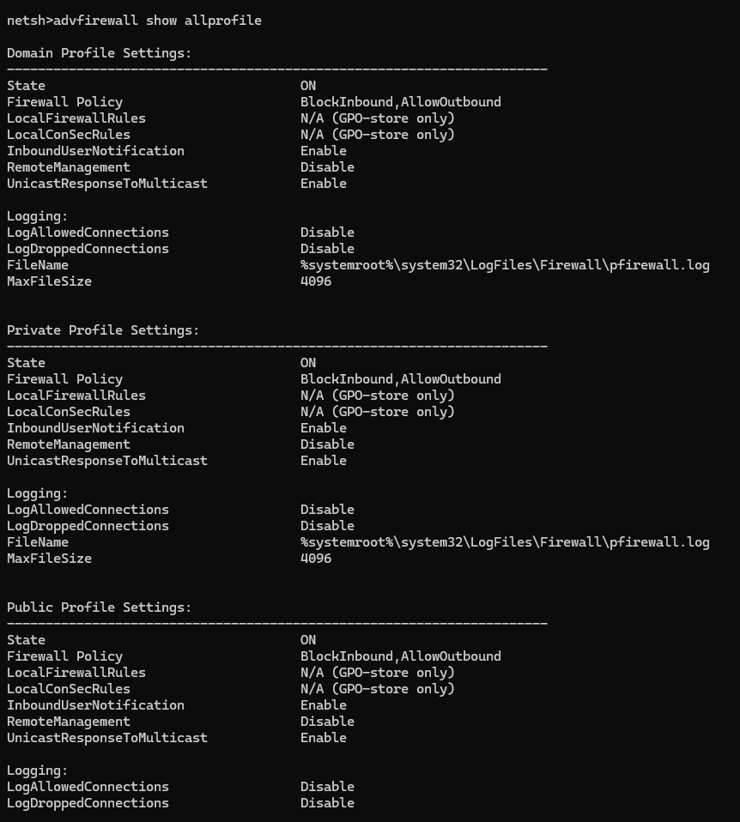

netsh>advfirewall show allprofile state
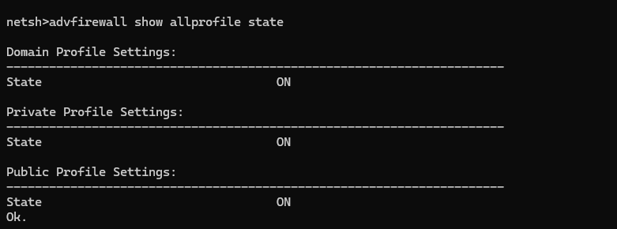
netsh>int tcp show global
